Hello, 10 B

Still waiting for some of your homework.

injection bandage nurse chemist plaster medicine ambulance X-ray dentist doctor tablets hospital

Fill the gaps

Put a___________on it so that it doesn't get infected.

An __________crew was called to his home, but he was dead by the time they arrived.

My ankle is rather weak, so I always put a ________on it to support it when I play tennis.

Daily insulin __________are necessary for some diabetics.

The __________bandaged my sprained ankle to keep the swelling down.

Penicillin produced a revolution in __________.

He worked as a nurse in a psychiatric__________.

He'd taken a sleeping __________the night before and still felt dopey.

The _________showed a slight irregularity in one lung.

I can't put off going to the __________any longer. My toothache is unbearable.

The ________have done some tests to try and find out what's wrong with her.

She worked as a __________for the water company.

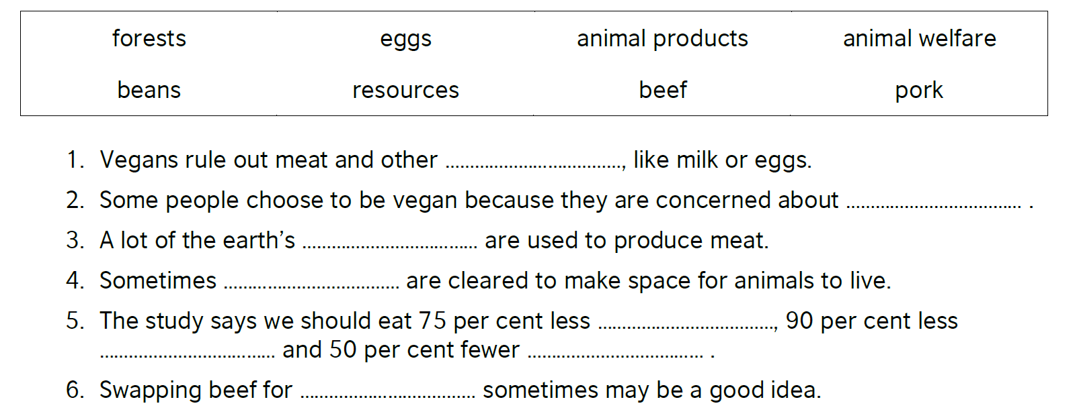

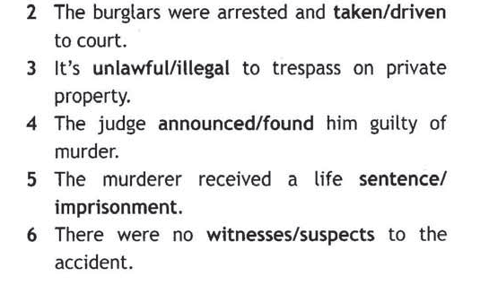

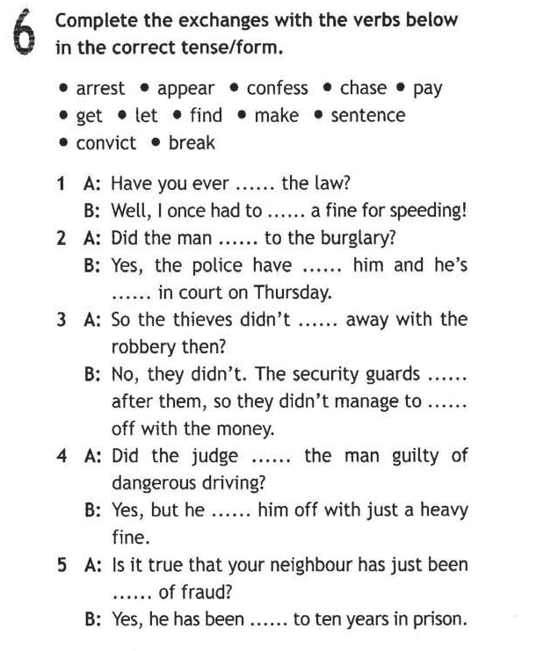

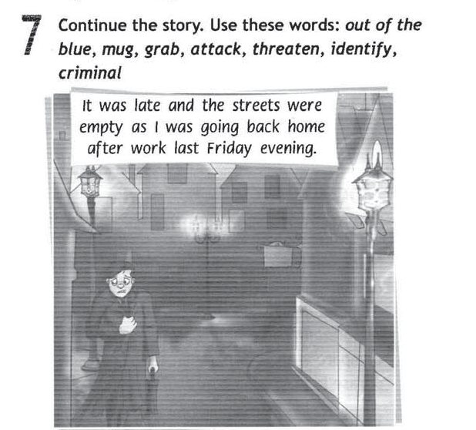

Write the story - 200 words.

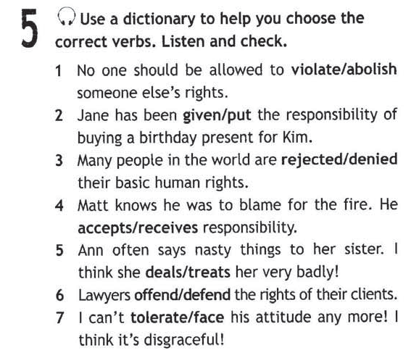

Watch this lesson in МЭШ

https://uchebnik.mos.ru/composer2/lesson/1308106/view

