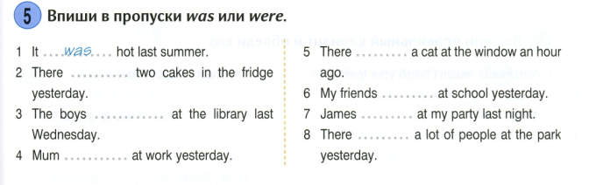
was / were
- There ______ bananas in the shop last week.
- There _____ milk in the supermarket last week.
- There _______ peaches on the table.
- There ______an apple in the basket.
- There ______ a farmer on the farm yesterday.
- There ______ eggs in the fridge.
- There ______ jam in the cupboard (буфет).

Put the verb in the correct form. Present Cont/ Present simple / past simple.

- We (wash) the dishes every day. My mum (wash) the dishes at the moment, she cannot talk. My sister (wash) the dishes yesterday.
- My baby brother (clean) his teeth every morning. I am busy now,I (clean) the room. We (clean) our classroom last week.
- John (play) board games last Sunday. My family (play) chess every friday. Susan (play) tennis now.
- We (go) camping every summer. My parents (go) camping last year. Look! he (go) home now.

