

О Write.
Positive ✓
- I drink milk.
- We play basketball.
- You take the bus to school.
- They read comics.
- We eat bananas.
Negative X
I don't drink tea.
We ..don't play football.
You don't take a taxi.
They don't read books.
We don't eat strawberries.
I don't get up at seven oclock.

- I get up at eight o’clock. 5

ф Write questions and answers.
- you / get up .Do you get up at seven o’clock?
Yes, I do.
No, they don't.
No, I don't.
Yes, they do
Yes. I do
- they / drink Do they drink juice in the morning?
- you / like Do you like cherries?
- they / take Do they take the bus every day?
- you / do your homework Do you do your homework
in the evening? 5

@ Look, read and write.
brush ✓
go ✓
like X
Do you watch TV every day?
Do you play
football every Saturday?
We don't eat
. . .
\ П177Л PUPrV flnvl
eat X
watch ?
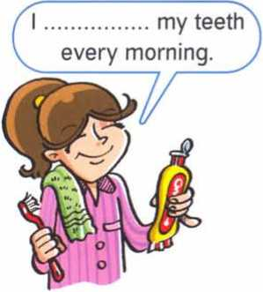
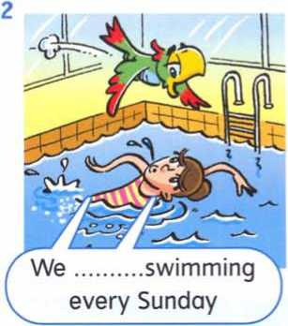
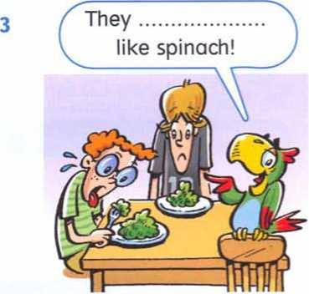
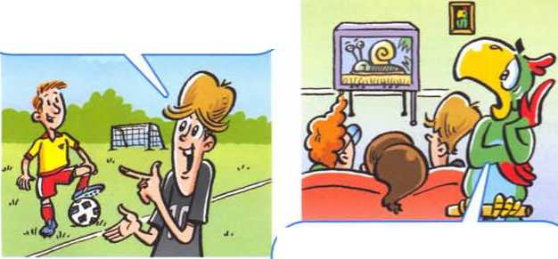
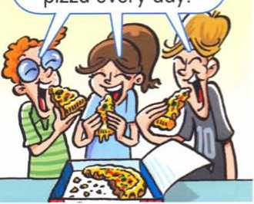
don't
brush

go

5

he, she, it (negative, question)
No. she doesn't!
Mmm! Chocolate cake!
It's for Vicky. Today is her birthday. Does she like chocolate cake?
doesn't like chocolate cake.
You're very naughty! Vicky loves chocolate cake!
She likes music!
Yes. but Dave doesn't know!
That’s right! Go and buy a CD for Vicky.
Positive
Negative |  | 1
He  She  It | does not  doesn't | like chocolate cake.  run fast.
likes chocolate cake. She . ₊
runs fast.
It
^Questions
he  Does she  it | like chocolate cake?  run fast?
Short answers
Yes, he | does.
she  No, it | doesn't.
/ We use the present^ simple to talk about facts.
Spelling rules: 3rd person singular
Verb + -s  - like likes  - play plays  - sit ■* sits  L | Verb + -es  - do ■» does  - go goes  - wash ~ washes  - watch watches  л
4

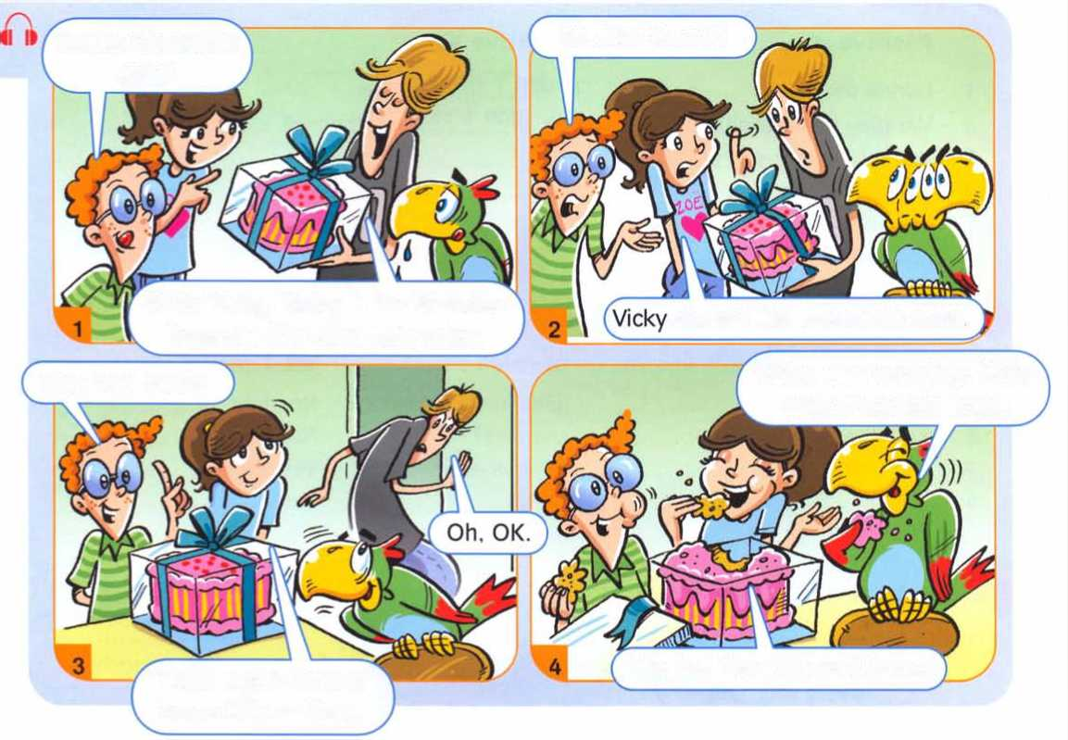





Negative A
She doesn't like
It doesn't drink
He doesn't buy
He doesn't play
She doesn't take
He doesn't eat
... spinach, orange juice. .. comics.
.. tennis.
... a taxi.
.. tomatoes.
Brian
Friday - v/a+ch TV Sa+urda\) - v/ash Dad’s car Sunday - do homework

о Choose and write.
Jik€ eat play buy take drink
Positive
- Vicky likes chocolate cake.
- The cat drinks milk.
- Brian buys books.
- Dave plays football.
- Zoe takes the bus to school.
- Corky eats ice cream. 5

© Read and write.
Zoe
Friday - play volleyball Saturday - get up at eleven o'clock Sunday - go to the park
- Zoe ..plays volleyball every Friday.
- She gets up at eleven o'clock every Saturday. / They do these things
- She goes to the park every Sunday. every weekend.
- Brian watches TV every Friday.
- He washes his dad's car every Saturday.
- He does his homework every Sunday. 5

0 Look at Exercise 5. Write questions and and answers.
- Does Zoe play volleyball every Friday?
...Уes, she does..
- Does she get up at seven o'clock every Saturday?
No, she doesn’t. She gets up at eleven o’clock.
- Does she go to the cinema every Sunday? No, she doesn't. She goes to the park.
- Does Brian watch TV every Friday? Yes, he does.
- Does he wash his Dad’s car every Sunday? No, he doesn't. He washes his Dad's car every Saturday..
- Does he do his homework every Saturday? No, he doesn't. He does his homerwork every Sunday. 5
Total: 5

