Упражнение, которое мы выполнялил - разбирали на уроке - запишите предложениями по примеру.
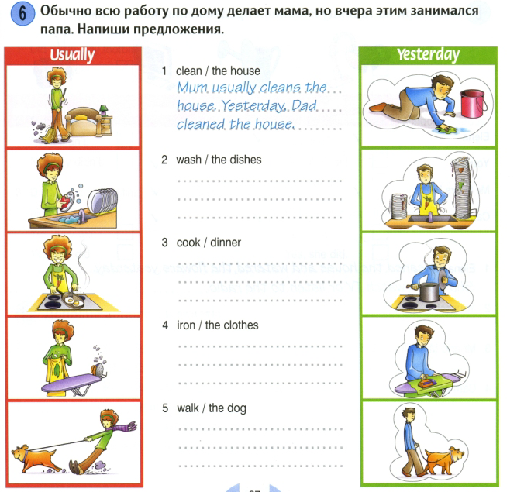

cinema cartoon film pop music drums relax watch listen theatre free time camera paint laugh смеяться stay in

- Julie is usually busy, but when she has some ______________ she reads books and _________ films.
- Peter can make so nice photos. Look at his ________ - it is very good and expensive. (дорогая)
- My favourite band is Abba and Hands up (Руки вверх) - I love ___________.
- Susan studies Art, she can __________ very well.
- Please, stop making this noise - шуметь, ________ is very noisy music instrument.
- We went to the _________ last week, watched a nice ________ Frozen2.
- I like spending free time - проводить свободное время on the beach, I can ________ and drink juice.
- I enjoy ________ to pop music.
- My brother is ill - болен now. So he __________ at home.
- The story was so funny, I _________ a lot.
- We sometimes go to the _________, I love operas (оперу) and drama plays.
