NAME Nadya Yakover
DATE 13. 05. 2020
CLASS 5 B
MARK 92/100 -8 5

40
(Time: minutes)
- Write the plurals, (мн.ч.)

ox oxen.+................
tooth teeth.+................
giraffe giraves --
- Strawberry strawberries +
- leaf leaves +
- piano pianos +
- Underline the correct item.
- Our / Ours father is Paul.+
- Bill is hers / her brother.+
- That’s not your book. It’s my / mine.+
- These shoes are her / his.+
- Sally has an iguana. Its / It’s name is Iggy.--
- Fill in you, he, she, it, we or they.

- watch wotches +
- deer deer +
man men +
Points: 8/-1
9x1 9
- These toys are theirs / their.+
- This is my / mine school.--
- This is my bag. It’s not your / yours.+
- Theirs / Their classroom is big.+
10 That’s John’s jacket. It’s he / his.+
Points: 8/-2
10x1 10

4. Change to the plural. Напишите предлож. во мн.ч..
- Brother he.+
- mobile phone it+
- Tom’s Dad he+
Points: 8/-1
9x1 9
- Peter and Pam they +
- Lorry she--
- Woman she+

you and Lily you
- geese they+
my friends and I we

- She’s got a balloon. They've got bolloons.+-
- That is a dolphin. Those are dolphins.++
- There is a guitar There are guitars.++.
- He can dance. They can dance.++
- I have a parrot They have parrots.-+
- That is a cherry. Those are cherries.++

- There is a deer. There are deer.++
- I can’t climb. We can't climb.++
- She’s a doctor. They are doctors.++ .
- I’m a student. We are students.++
- This is an ostrich. These are ostriches.++
- He is a pilot. They are pilots.++
Points: 22/-2
12x2 24

X
Test 5 J
- Write the questions and answers.
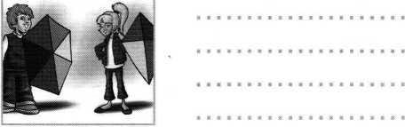
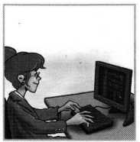
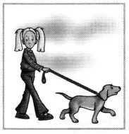
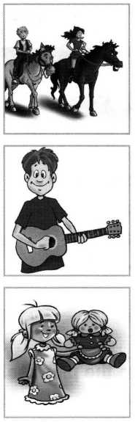
ddd
3 Jim / guitar
Has Jim got a guitar?.
Yes, he has.
It's his guitar.
It's his.
Have they got kites?
Yes, they have.
They are their kites.
They are theirs.

1 Paul and Mary / horses
Have Paul and Mare got horses?
Yes, they have.
They are their horses.
They are theirs.

Ann / computer
Нйй Лпл дойй, ....

camput&tf.........

Y%?„ she Ms.,......

/t s her .wmputer., It’s hers,...........
2 they / kites
I
i
Points: 19/-1
5x4 20
5 Sue/doll
Has Sue got a doll?
Yes, she has.
It's her doll.
It's hers.
Has she got a dog?
Yes, shi has.-
It's her dog.
It's hers.

- Choose the correct item.

These are not their books. Ayours В their
C mine
7 Nina and I are
A am
ten years old.+
' В is C are
+

tail! +
В monkeys’ C monkey’s
2 Look at the monkey's monkeys
3 Are they. firefighters?+
A they В theirs C their
.

8 Have George and you got a camera?+

A Have В Hasn’t C Has

9 This is his CD. It’s his.+

A hers В his C he

10 Please don't talk in the classroom!+
A her | В his | C hers
5 Is this an.. | octopus?+
A a | В an | C these
6 A frog can | jump.+
A can | В is | C has got
4 This is Mrs Brown’s bag. It’s his--
A do В
I 11 That is the children's
A childs’ В
12 This robot is mine!+ A mine В
let’s | C | don’t
school.+
children’s | C | childrens’
your | c | our
 | Points: 11/-1 \
12x1 12

- Write the questions and answers with can.
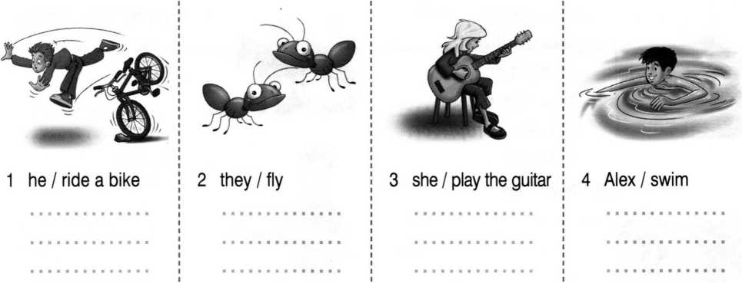
Points: 12
4x3 12
Can they fly?
No, they can't.
Can Alex swim?
Yes,he can.
Can she play the guitar?
Yes,she can.
Can he ride a bike?
No, he can't.

Please close the window! Do your homework!
- Match the following to the pictures.
Please don’t talk!
Let’s dance.
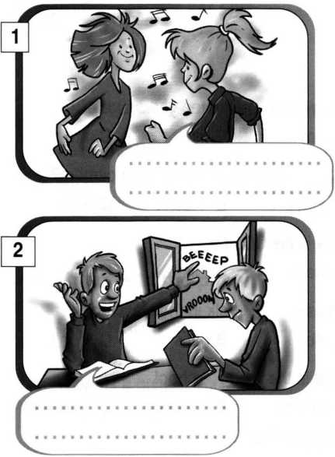
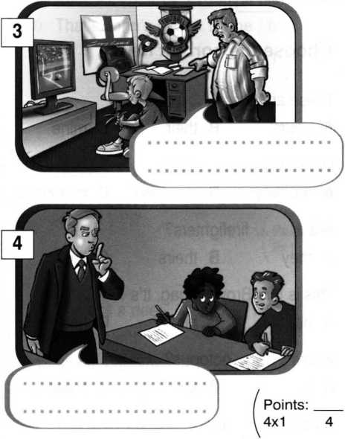
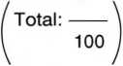

Do your homework!
Let's dance.

Please don't talk!
Please close the window!

